Media Process Framework
Architecture Overview
Version: 0.1

Revision History
Date | Version | Description | Author
1/10/2005 | 0.1 | Initial draft | Hui Shao
Table of Contents
1. Introduction 6
1.1 Purpose 6
1.2 Definitions, Acronyms, and Abbreviations 6
1.3 References 6
1.4 Design Principles 6
1.5 Requirements on Other Components 7
1.5.1 Filter-ed process modules 7
1.5.2 Management application 7
2. Overview 7
2.1 Architecture 7
2.1.1 Task Execution 8
2.1.2 Node Communication 8
2.1.3 Resource Management 8
2.1.4 Session Management 8
2.2 Reliability and Availability 9
3. MPF Nodes 9
3.1 Worker Application 9
3.2 Manager Application 9
3.3 Node Identification 9
3.4 Stages 10
3.4.1 Worker Nodes 10
3.4.2 Management Nodes 10
3.4.3 Deployment 10
4. MPF Filter Development Basic 11
5. Worker Application 11
5.1 Worker COM Control 11
5.1.1 WorkTask ActiveX Objects 11
5.1.2 Worker Control Thread 12
5.1.3 Interactions between Active Objects and the Control 14
5.1.4 Class Diagram 15
5.2 Task 15
5.3 Filter Collaboration 16
5.3.1 Event Notification and Handling 16
5.3.2 Progress Presentation and Control 16
5.4 Worker Proxy 16
5.5 Worker Application 16
5.5.1 WorkTask Wrapper Façade 16
5.5.2 Sample Application 18
6. Management Application 20
6.1 SRM API Layers 20
6.2 MetaRecord and Directory Access 20
6.3 Stub Description 21
6.4 Stub Server Objects 22
6.5 Session Access APIs 22
6.6 Resource Description 23
7. Resource Management 23
7.1 Resource Discovery 23
7.1.1 Active Registration 23
7.1.2 Centralized Query 24
7.2 Resource Status Update 24
7.2.1 Periodic Report 24
7.2.2 Centralized Query 24
7.3 Resource Allocator Template 24
7.3.1 Interfaces 25
7.3.2 Basic Allocate Algorithm 25
7.3.3 Scoring and Template 26
7.3.4 Resource Booking and Reservation Handles 27
8. Service Provider 29
8.1 Windows Service 29
8.2 Task Management 29
8.2.1 Service Provider WorkTask 29
8.2.2 Task Definition Loader 30
8.2.3 Internal Monitor Loop 30
8.3 Task Acceptor 30
8.3.1 Request Argument Mapping 30
8.3.2 Sample Task Request 31
8.3.3 Task Context in the Session Record 31
8.3.4 Task Request API 31
8.3.5 Dummy Session 31
8.4 Service Publisher 31
9. Task Definition Language 32
9.1 Task Type Naming 32
9.2 Filter Enumeration 32
9.3 Local Dependence Validation 33
9.4 Pin Connections 33
9.5 Request Parameter Mapping 33
9.6 Sample Task Definition 33
10. SRM Service 34
10.1 Service Provider Resolving 34
10.2 Resource Management Plug-in Architecture 34
10.3 User’s Interface 34
11. Task Collaboration 34
11.1 Tasks’ Relationships 34
11.2 Chain-up Tasks for a Session 34
11.3 Hot Swap 34
12. Error Handling and Fail-Overs 34
12.1 Local Database vs External Database 34
12.2 Worker Application Service Fail-Over 34
12.3 Management Application Service Fail-Over 34
12.4 External Database Fail-Over 34
13. Supplementary Illustration [optional] 34
14. Issues and Considerations [optional] 34
15. Appendix 35
15.1 Active Object Threading and Communication 35
15.1.1 Active Object Threading 35
15.1.2 Communication between Active objects and the control 37
15.2 GetOpt Description Sample 37

Introduction

Purpose
This document specifies the general architecture and components for the ZQ Interactive’s Media Process Framework (MPF). Initially, the focus of MPF is to define uniformed and managed application structure in a distributed network environment.
- Chapter 1, 2, 3 will describe the basic concepts in the MPF
- Chapter 4, 5, 6 will describe the components in the first stage of MPF applications
- Chapter 8, 9, 10 will describe the components in the second stage of MPF applications
- Chapter 7, 11 and the later ones will describe some general topics about MPF
For the people who are only interest the stage one applications, he/she can skip chapter 8, 9 and 10.

Definitions, Acronyms, and Abbreviations
Name | Description
MPF | Media Process Framework

References
[R01] Reference 01

Design Principles
The key design principles for the Media Process Framework are as follows:
- In a MPF application deployment, all the worker nodes provide specified services to the users will be under management of one or more MPF manager node.
- All the resources that external to a worker node and will be used to complete the service will be under the management of one or more MPF manager node
- User’s session is maintained in the manager node, and is required to launch a task on a worker node
- DirectShow architecture is the one to follow to assemble up a specific task

Requirements on Other Components
MPF is intended to integrate into the DirectShow architecture with minimal changes on a head-end distributed network environment to serve user’s requirement. The following sub-sections present changes to various components that are necessary to allow correlation between certain standard operations within the system.

Filter-ed process modules
Any task performed on a worker node will be chained with DirectShow-style filters. The atomic data process should be defined in a single filter. MPF requires all existing applications divide their process into filter implementations.

Management application
The management application can take benefit from the MPF management API. However, for the existing management applications, they are required to switch to invoke the new management API.

Overview

Architecture
The MSA consists of
- the distributed worker nodes that take the process tasks,
- management nodes which is the central collection components of resource management and session management, and
- their interactions for exchange data, status and events
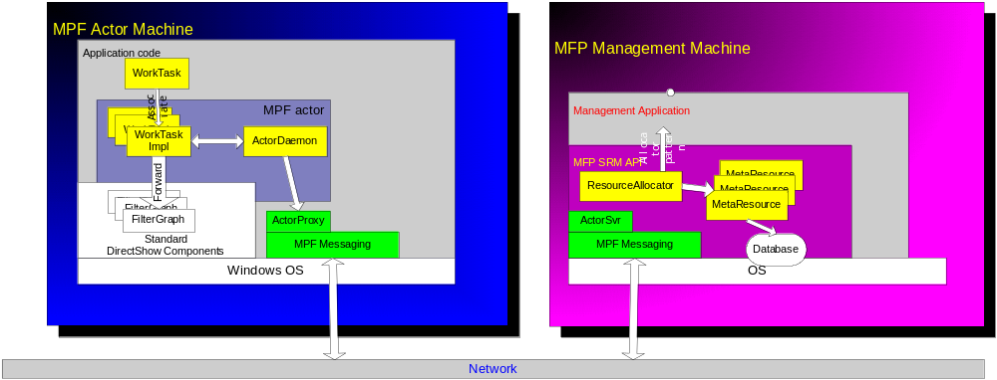Those components or modules are presented in Figure 2.1 and described in more detail in the later chapters.
In the space of Media Process Framework, all the involved machine can be separated into two classes:
- MPF worker node – the machine with at least an application that invokes MPF WorkCtx run on it
- MPF management node – the machine with at least an application that invokes MPF SRM API run on it

Task Execution
In a single MPF worker node, task as a sequence of processing steps can be executed and completed via a DirectShow-style filter chain. The ability of an MPF worker node to serve a specific type of task is implemented by assembling several filters registered on the node. Each task belongs to a specific session in the space of MPF management.
A work task is an individual thread for the up-layer user application. The user application can operate the task for starting, pause or stop. All the work tasks are under management of a unique thread call worker thread. The worker thread is an aggregator of work task instance; it is also a proxy to communicate with the management nodes.

Node Communication
MPF provides several communication methods between the MPF nodes, the primary method is PersistRPC. PersistRPC is a messaging implementation on a fault tolerant connection.

Resource Management
MPF provide the predefined resource management to minimal the development load. The MPF resource management is focus on the external resources that is required to complete a task in a worker node. The internal resources within a worker node should be managed by filter or the user application itself.
The worker thread automatically reports the worker node resource status to the related management nodes that are interest with it.
The resource management will be well utilized when assigning a task to a work node.

Session Management
In an MPF node group, a session includes a complete set of attributes to describe the session status and task status. Its lifetime is from a user enter the MPF system to his leaving.
A session may contain several tasks; those tasks can be either executed serially or simultaneously.

Reliability and Availability

MPF Nodes
This chapter lists the components in a MPF worker node to represent how the worker node performs the task executions and interact with the MPF management nodes. And also describe how a user application can be benefited from it.

Worker Application
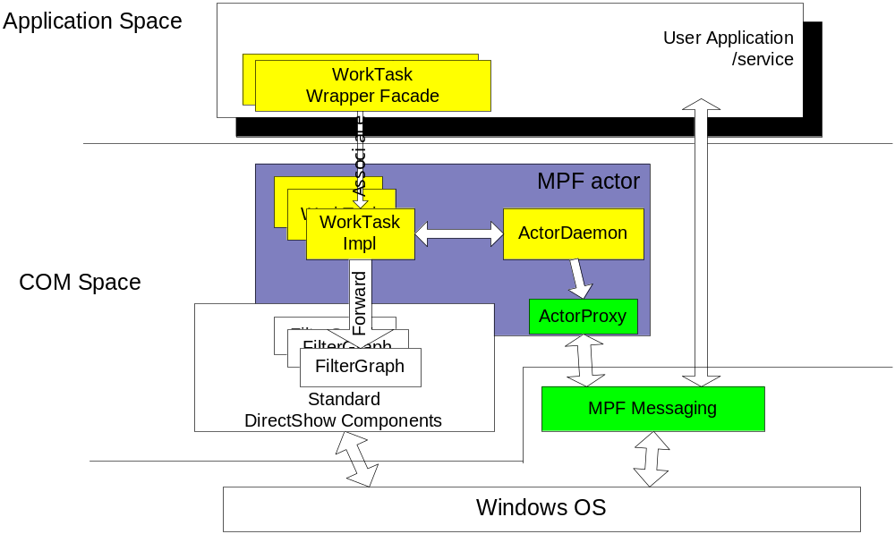An MPF worker node is a machine that has at least one application invoking MPF WorkCtx COM control running on it. Those applications are called as MPF worker application shown in the Figure 3.1. It covers both user-development worker application and the MPF service provider, but it is usually the first one in this document if there are no special prescriptions.

Manager Application
An MPF managment node is a machine that has at least one application invoking MPF SRM API running on it. Those applications are called as MPF management application shown in the Figure 3.1. The concept covers both user-development certain task-oriented management application and the MPF SRM server, but it is usually the first one in this documents if there are no special prescription.

Node Identification
Every MPF node has a global unique identification, this identification exists in the below registry as a GUID string:
[HKEY_LOCAL_MACHINE\SOFTWARE\ZQ Interactive]
[HKEY_LOCAL_MACHINE\SOFTWARE\ZQ Interactive\MPF]
"NodeID"=""
When the WorkCtx or the SRM API gets loaded, the subsystem will open the registry to get the ID. A new ID will be generated and save if the ID in the registry does not exist previously.

Stages

Worker Nodes
The work application can be classed into two stages:
- User’s work applications
The applications are developed by user to connect the registered filter into a filter chain to serve specific type of tasks.
- MPF service provider
Is a special implementation of MPF worker application that loads external configurations to build up pre-defined task chain. The service provider publish its task abilities and capabilities to others in the domain of MPF
The key to separate the deferent stages of the worker applications is how they invoke the WorkCtx

Management Nodes
The management nodes can also be classed into two stages:
- User’s management applications
The applications are developed by user to take the benefit on resource and session management provided by MPF SRM API to manage one or several specific type of MPF tasks.
- MPF session & resource management service
Is a special implementation of MPF manamgemnt application that provide a flexible and extendable resource discovery on external resources, and many pre-defined session and resource management rules to cover the current usage of ZQ applications and future purposes

Deployment
In the first stage of media process framework deployment, for a worker node, it must have:
- The WorkCtx COM control registered
- A dynamic link library PersistRPC.dll provides the XML-RPC over persistent fault tolerant connections
- The user developed worker applications
For a management node, it must have:
- A dynamic link library MPFSRM.dll provides the generic session and resource management APIs
- PersistRPC.dll provides the XML-RPC
- And the user developed task-oriented management applications
Of course, both work application and management application are possibly deployed on the same machine.
In the second stage of media process framework deployment, for a worker node, the user developed worker applications will be replaced with service provider, a new service to load task definitions to provide certain types of tasks.
The management applications will also be archived into a new existence, MPF SRM server.

MPF Filter Development Basic
To be detailed

Worker Application

Worker COM Control
WorkCtx is the key component on a MPF worker node. It is implemented as a Windows COM control.
WorkCtx includes two classes of basic instances:

WorkTask ActiveX Objects
Represent work tasks on the node. Each object
- Basically works as a redirector to DirectShow’s standard FilterGraphBuilder implementation, this provides the up-layer a normal FilterGraphBuilder ability to assemble filters into a filter chain and perform a complete data processing. The usage and development of DirectShow filter will be described in the chapter of Filter development
- Works a task proxy to the management node, it attach the current task into an MPF session, get and put the session variables, update the task and session status.

Worker Control Thread
This is a unique background thread in the control, it
- Works as an aggregator and manager of all the WorkTask instances to monitor their creations, destruction and runtime status
- Works as a proxy of the work node to the management node. It announces its existence and also reports the machine status such as CPU usage to the management node.
- Works as a service information publisher to other nodes in MPF. The information to be published will include both the ability to serve different type of task and the capability to serve the same tasks simultaneously
Sequence diagrams
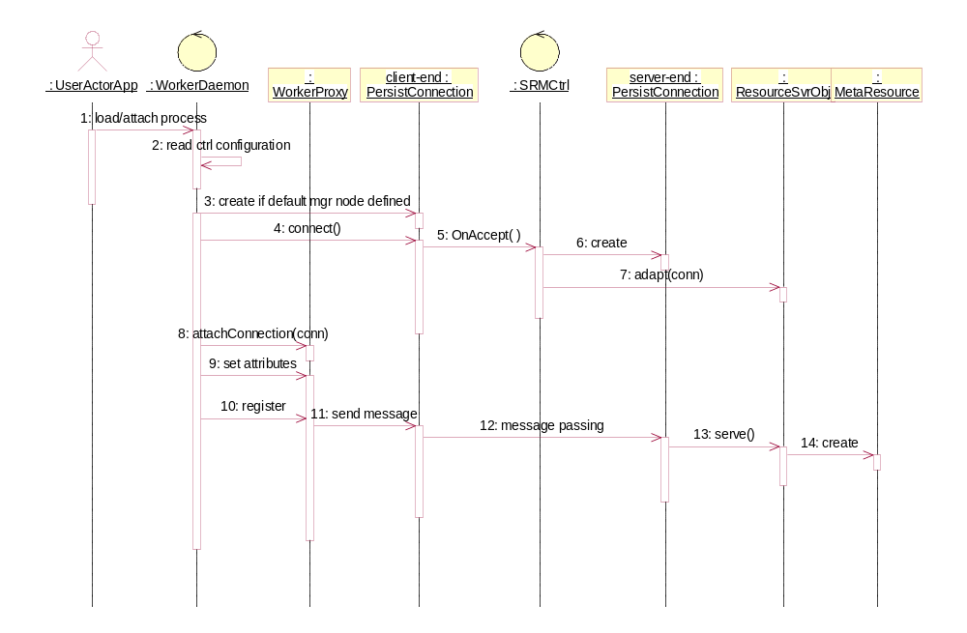
Figure 5.1 Control Initialization
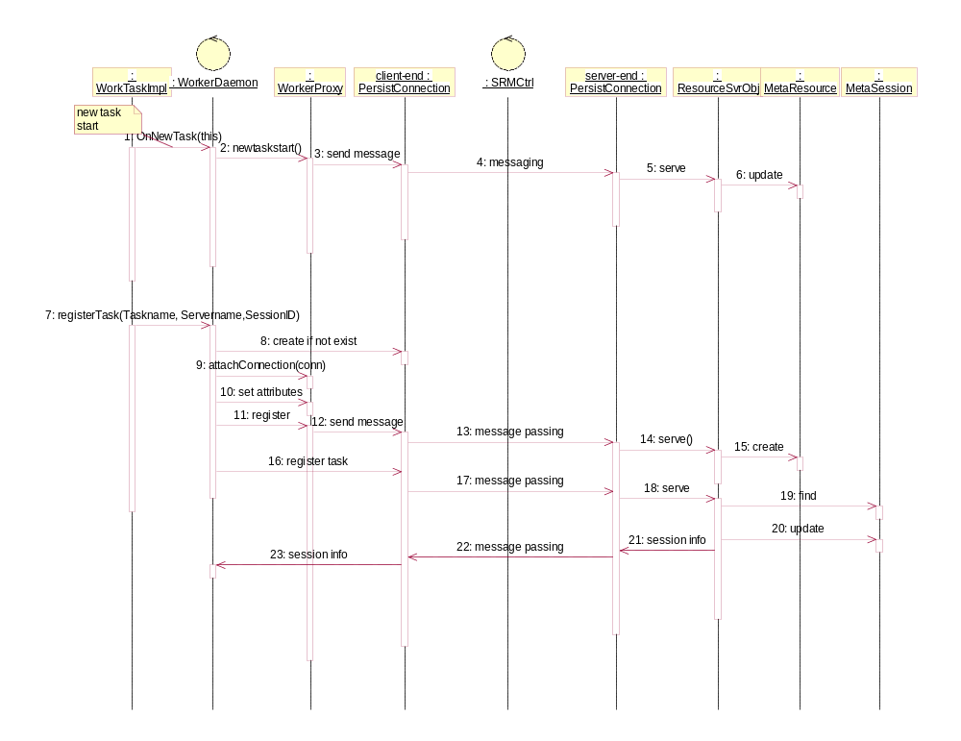
Figure 5.2 New WorkTask starts
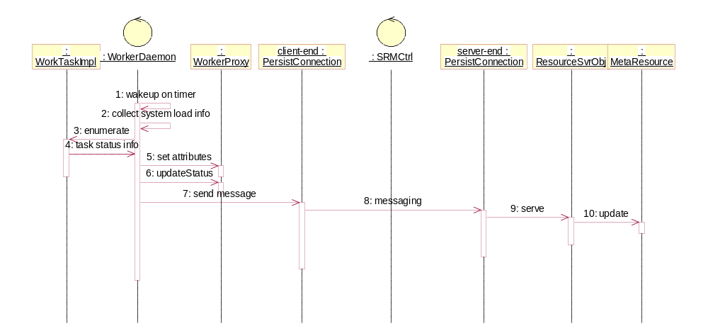
Figure 5.3 Heart-beat

Besides the above two basic classes of instances, the WorkCtx is running on the PersistRPC layer to communicate with the management nodes. The PRC calls are defined in the WorkerProxy which is a part of the Worker Thread

Interactions between Active Objects and the Control
WorkTasks are individual threads that are the aggregated items of the control thread, and they communicate with the management node via the control thread asynchronously some time. Please refer to the Appendix I for more detail on how the multithread ActiveX control be implemented.

Class Diagram
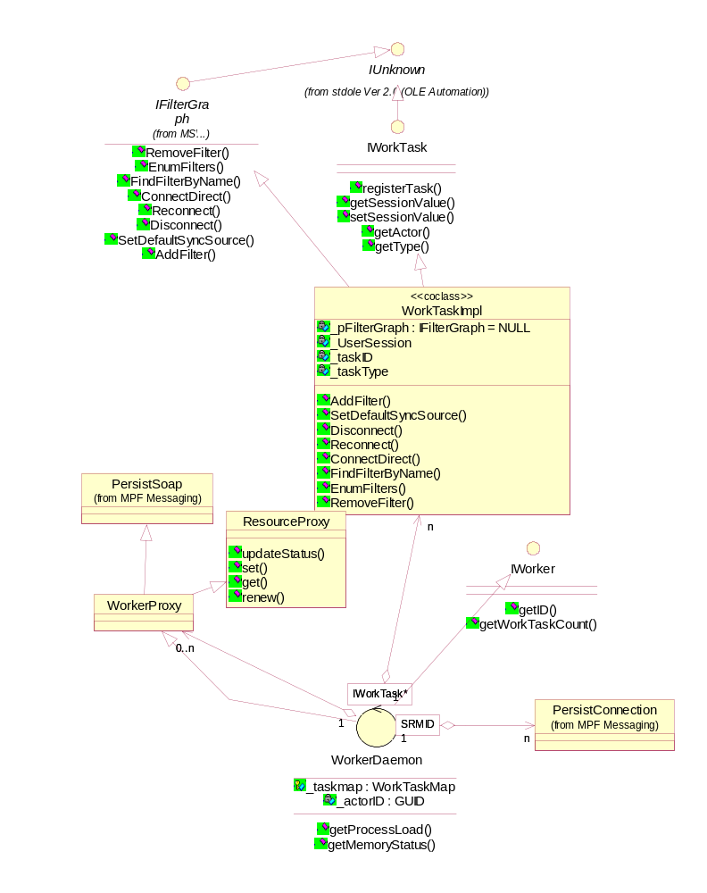

Task
From the view external to the work node, task is the minimal unit that can be performed on a single machine. A task is made up with several DirectShow style filters which are assembled into a single filer chain. The WorkTask ActiveX object above is the container and monitor of this filter chain.
In a MPF deployment, any one single task must belong to a single MPF session logically. Tasks are the practical complementarities of the MPF sessions. Every work task will be under management of the MPF session management

Filter Collaboration

Event Notification and Handling
TODO:

Progress Presentation and Control
TODO:

Worker Proxy
This module is responsible for all the communications with management nodes, it is built based on the XML-RPC over a persist connection. The persistent connection is a SeaChange fault-tolerant connection implementation, which provides a transparent fail-over and re-connect mechanism.

Worker Application
A worker application is an application that invokes MPF WorkCtx COM control. It inherits from MPF WorkTask wrapper façade (will be described later in this section) and override with its own filter chain assembling and runtime monitoring logic to provide or support one type of tasks.

WorkTask Wrapper Façade
The wrapper façade inherit from the object-ed thread, and provide the automation on how to access the WorkTask ActiveX object and WorkerThread in the MPF WorkCtx. It also covers many default work task steps, and can be customized on filter assembling and runtime monitoring.
Class diagram
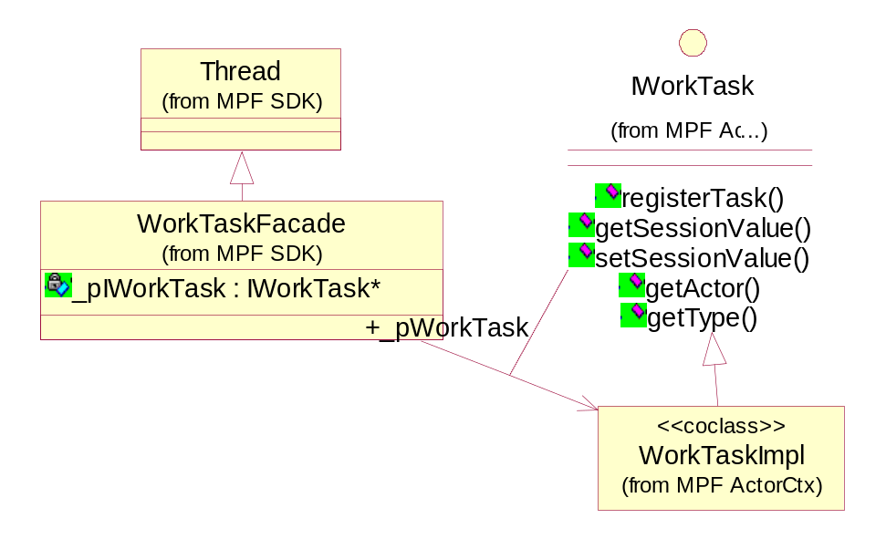
Methods
The methods can be divided into the following groups:
- Thread based operations, defined in the objected thread, the initialization and run implementation must be overridden in the specific task implementation which is inherited from this class. The initialization will focus on the filter chain assembling and validation. The ‘start’ operation will lead to the ‘run’ implementation which starts the filter chain.
- FilterGraph operations, covers the steps to include filters in the work task, connect them into a chain, start, pause and terminate the chain functionalities.
- WorkTask operations, covers the session variables access and task/session status update

Sample Application
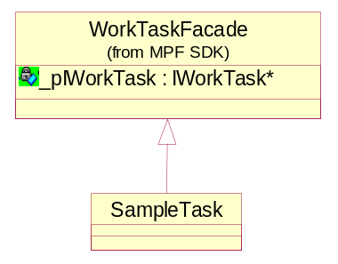 | 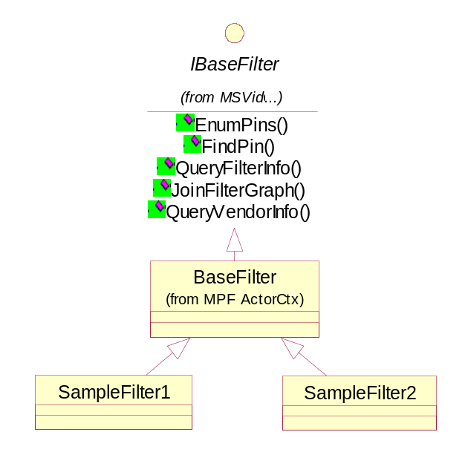

Sample Filters
They can be third-party filters or MPF filters. The MPF filters inherit from MPF basefilter which put the filter under resource management of MPF.
Please refer to the chapter of MPF Filter Development Basic or DirectShow documentations for more detail about the filter development.
Sample Task
The SampleTask is an implementation of WorkTaskFacade, it assembles related filters into a specific chain then adopts the filter operations to the thread operations
Sequence Diagram
The following sequence diagram briefly shows how a sample work application works
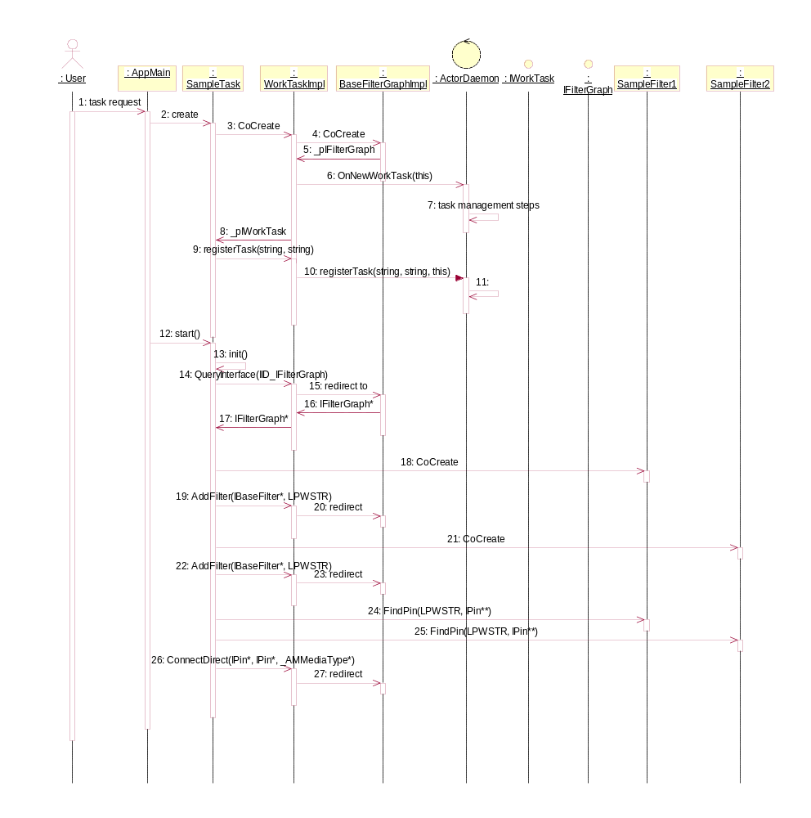

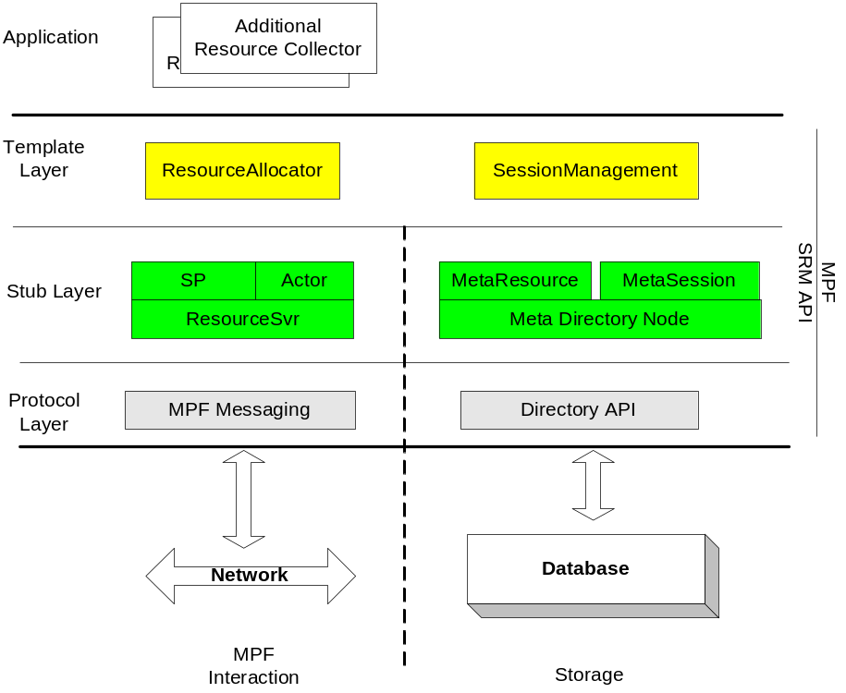Management Application

SRM API Layers
The MPF SRM API provides open capabilities on resource and session management. As shown in the figure 6.1, the SRM API is mainly focus on three topics:
- The management template
- Interactions with other MPF nodes
- Data storage access for the managed records
The API can be divided into three layers:bb
- Template layer
- Stub description layer
- Protocol layer

MetaRecord and Directory Access
In MPF SRM, data is stored as record node in a directory organized data storage, every directory node will be represented as a meta record. A meta record is a structured data with a key-to-value map.
Every metarecord in a directory will be uniquely identified via its location entry in that directory, for example,
/local_machine/Sessions/1234567890
The entry will be delimited into different folder level by “/”, and the root of a directory will be marked as “/”.
Class diagram
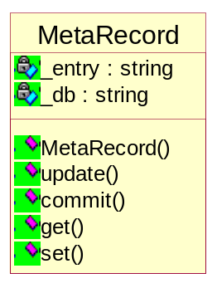
Constructor
MetaRecord(string Entry, bool CreateIfNotExist = ture);
Methods
bool update(void);
bool commit(void);
string get(string name);
bool set(string name, string value);
The default directory structure
The following is a pre-defined directory structure for SRM:
/
/local_machine/
/local_machine/sessions
/machines/
/machines/<GUID>
/resources/
Some default setting information must be kept to maintain the directory structure. So every folder will have a directory node called ‘.’ in that folder, for example, the folder
/local_machine/sessions
will have a node called:
/local_machine/sessions/.
Which keeps the maximal session id has been generated for the next new id.

Stub Description
In a management node, the information is organized as meta data and kept in some entity records to describe the resources and the run-time sessions.
Class diagram
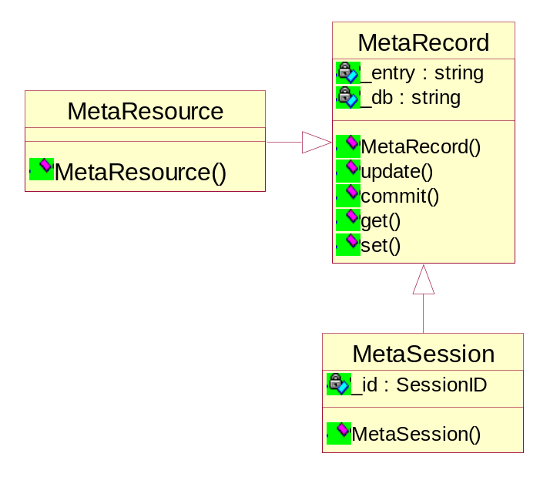

Stub Server Objects
Those stub server objects work as the server-side of the client proxy objects (e.g. worker proxy in work application). They response the requests from the client proxy objects via XMLRPC over persist connections. The objects will also access the meta records in the directory database.

Session Access APIs
In this module, all the access method to the session information will be defined. Every MPF will have a session id.
Root entry
Any local created session will be put in the folder of
/local_machine/Sessions
Those entries for the sessions will be identified with an auto-incremental unique number that is also called as the session id, for example:
/local_machine/Sessions/1234567890
Class diagram
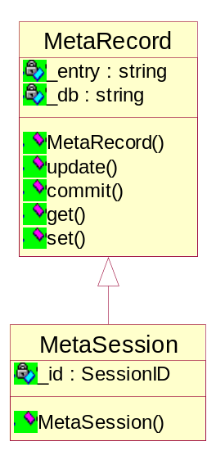
here the MetaSession inherit all the meta data access from MetaRecord
Constructor
MetaSession(string ID, bool CreateIfNotExist = ture, string ownernode=NULL);

Resource Description
The resource in an SRM directory will be described in two ways: by the host machine, and by the resource type. The host machine based records describes the information about the specific machine which includes its CPU, memory, IP address and so on. Those information can either reported by the WorkerDaemon thread in the WorkCtx or filled in by the user/third party application. The resource class-ed records are put under /resources/<type>. Those records will describe the specification and status about those resources, a required field in each record will mention the GUID link to the machine description under /machines/.
/machines/12345678-1234-1234-1234-123456789012
/resources/FtpServers/0001

Resource Management

Resource Discovery
In MPF, resource discovery is archived with active registrations and centralized queries.

Active Registration
For the MPF nodes, the WorkerDaemon thread is the unique agent of the hosted machine, it register itself to the management node and pushes the machine information and status to the management node. Also, it works as a proxy to report the general work task status to the management node.
As the process to response such registrations, the management will create resource meta records and flush the resource description and status into external database.

Centralized Query
For those application specified resources, they will be queried by the management application centrally since there are so many various resources.
Resource Collector
This per-resource-type implementation query the specific resource at all possible machines and then fill-in the resource meta records into the database. This step may invokes different API in order to determine the detail resource description or status.
Resource Collector will be exported as a part of resource allocator by the MPF SDK as a template, please refer to the resource allocator template for more details

Resource Status Update

Periodic Report
The WorkerDaemon not only reports such information at the events of daemon starts/ends, task start/end, but also send the information as heart-beats to reflect its health. As the process to response such reports, the management will open the related resource meta record and flush the update into external database.
Lease Mechanism
The management responses the reporting with a lease term, which requires the worker node to send next heat-beat no later than the lease gets expired, otherwise the management node will trust that worker node unavailable.

Centralized Query
The Resource Collector can not only query for the existence of the resource but also periodic query for the runtime status of the resource.

Resource Allocator Template
In MPF, the resource allocator are per-resource-type implementations, which means every type of resource will as its own resource allocator implementation. MPF SDK exports the foundational resource allocations as templates to give an open usability.
The resource allocator supports resource allocation and free. Also, for the centrally queried resource, the allocator can embed the resource collector with it.

Interfaces
The resource allocator supports the following interfaces:
Allocate
When a resource is requested, it is removed from the available resource queue and the pointer to the resource is passed to the caller.
Free
When a resource is freed, it is added back to the available queue.
Add
If a resource is detected through resource discovery, the allocator provides a way to put the resource identification into its available resource stack or queue.
Remove
If a resource is detected its unavailable, the allocator provides a way to remove the resource from its stack or queue.
The stack or queue may not exists in the in-memory storage, they can be also implemented by accessing the resource directory database.

Basic Allocate Algorithm
A simple resource allocator can be implemented by using the queue and the stack container adaptors. The container adaptors are used to maintain the free list of resources.
Coldest First
In coldest first resource allocation, the resource not allocated for maximum time is allocated first. To implement this first in first out, FIFO type of allocation, the resource allocating entity keeps the free resources in a queue. A resource allocation request is serviced by removing a resource from the head of the queue. A freed resource is returned to the free list by adding it to the tail of the queue
Hottest First
In hottest first resource allocation, the resource last released is allocated on next resource request. To implement this last in first out, LIFO type of allocation, the list of free resources is maintained as a stack. An allocation request is serviced by popping a free resource from the stack. When a resource is freed, it is pushed on the free resource list.
The "coldest first" resource allocator can be changed to "hottest first" resource allocator by simply replacing the queue with a stack.
Comparison
The ‘hottest first’ can make the first available resource very busy but the last resource quite idle. The ‘coldest first’ can distribute the load on available resource more widely than hottest. However, it has higher risk that the allocated resource may not available since it is not verified recently.

Scoring and Template
To give a flexible resource allocation method, MPF provide resource allocation template with the user-define scoring API.
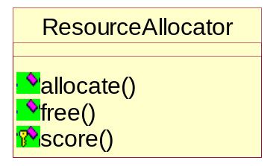
Customize-able scoring
virtual byte score(MetaResource& res, const MetaSession& sess)
When the allocate() is called, the allocate will score each available resource by calling score() method that is implemented in the detailed allocators, the child classes. The score() will evaluate the input resource via its own rules, then return with a integer in the range of 0 to 255. Where 0 mean that resource can not be used, and 255 means that resource is highly recommended to use. In such a definition, user can define the resource allocation in a very flexible point. For example, an MCA node allocation can be:
BYTE MCAAllocator::score(MetaResource& res)
{
// test if the resource type is “MCA”
string value = res.get(“type”);
if (value != “MCA”)
return 0;

// test if the resource has enough bandwidth
value = res.get(“availableBandwidth”);
string expectvalue = sess.get(“ExpectedBandwidth”);
if (value.toIntVal() < expectvalue.toIntVal())
return 0;
// okay, this is a resource that can serve the request, now score it with CPU load and memory usage
// collect the system information
…
// put your magic here to score this resource
int iscore = 1+ min((UnusedCPUPercent/10), (FreeMemory / 1024/1024/32));
return (iscore > 255)? 255 : iscore &0xff;
}
Allocate from scored resources
Once every resource has been scored in the range 0-255, the allocator will line them with their score number length, those 0-scored resources will be excluded. For example, if there are five resources with scores 2,10,5,0,22, a line will be created like:
Offset | 0 | 2 | 12 | 17
 | R1 | R2 | R3 | R5
A random number in the range of 0 to 39 (total scores) will be generated to decide which resource will be used. Say, if the random number is 20, it is in the range from 17 to 39, then the resource R5 will be allocated. In such an algorithm, higher scored resources will be allocated at higher possibilities than those have lower scores; zero-scored resources are unqualified and will never be allocated.
The override-able sore system gives a flexible method to qualify and balance the resource allocation.
Once the allocation is determined, the resource availability must be decreased from the MetaResource record.

Resource Booking and Reservation Handles
Resource booking append resource allocation with a time dimension.
The resource booking allocator will maintain a link of resource usage description nodes. Each such node has the fields of usage start-time, end-time, booked volume, and of course a reference to the resource. Meanwhile, the booking allocator has a total resource count with it.
The following is an example of the resource booking status at a certain time:
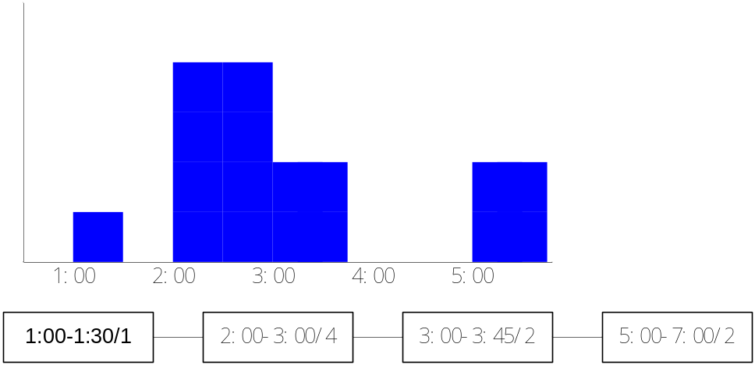
Suppose the total resource count is 4, at the initial time
- One unit of the resource has been booked for 1:00 to 1:30
- Four units for 2:00-3:00
- Two units for 3:00-3:45
- Two units for 5:00-7:00
If a request is received to book the resource for the time period from 1:00 to 3:00 at volume of 1 as represented in the below diagram, the allocator will scan the node link to try to add 1 for the period 1:00 to 3:00. When it reach the old 2:00-3:00 node, it detected that the resource usage will exceed the total available resource, it rejects the booking.
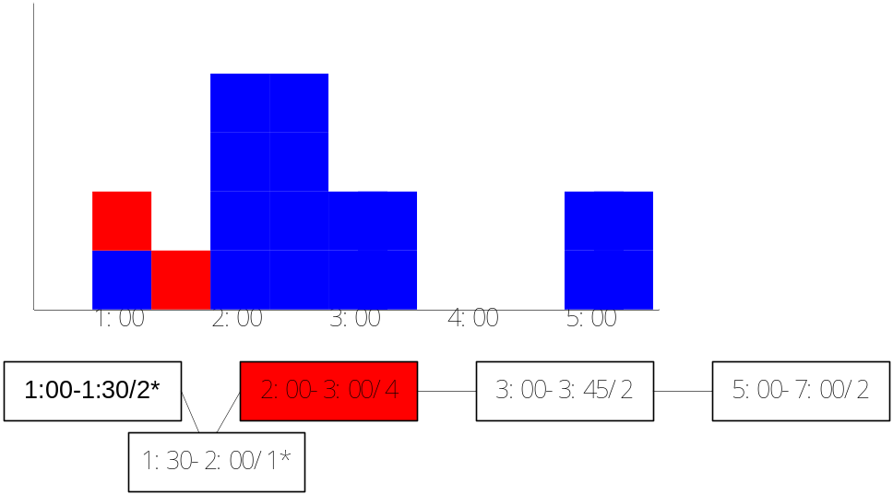
If a request is received to book the resource at volume of one for 3:00 to 4:45 as represented in the diagram below, the scanning can go through successfully, the allocate replaces the old 3:00-3:45 node with two new usage nodes: 3:00-3:45/3 and 3:45-4:45/1
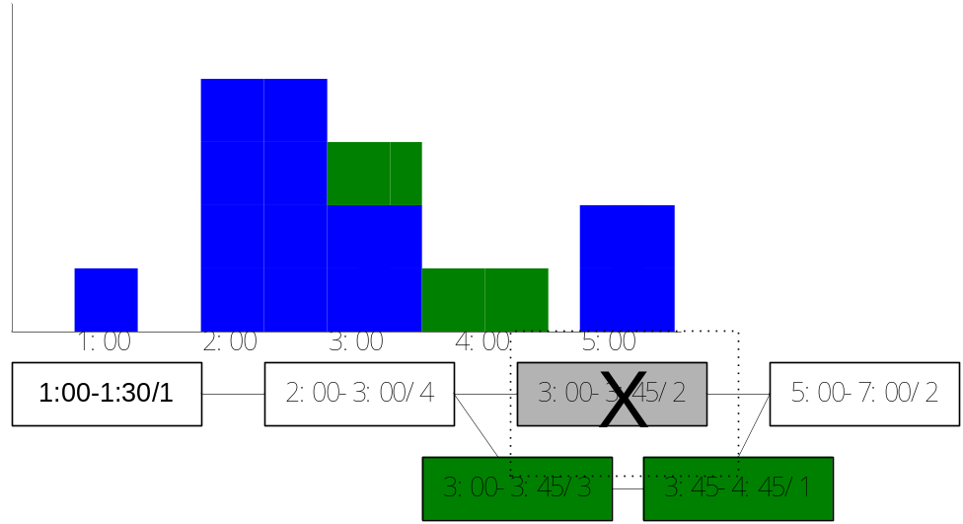
For the booking algorism, a handle to the booked resource is generated and directly save into the related session record. Anytime when the resource is about to free, the reservation handle will be required.

Service Provider
MPF Service Provider is an advanced stage of the worker application with general processes on task definition, initialization and execution. Unlike the user’s worker applications, service provider will not ask to code directly to chain the related filters up in a common programming language. Instead, it defines a task definition language to allow user configure the specific functional filter chain as the task ability of that worker node.

Windows Service
MPF service provider is a Windows NT service that automatically loads the WorkCtx during its start. At this point, the service provider is a MPF worker application.
The service provider is implemented as a SeaChange-style service so that it is benefited with the failover mechanism, SNMP support and more features from the SeaChange service framework.

Task Management
In the stage of service provider, all WorkTask become a uniform definition, which means the user-coded WorkTasks are eliminated from this stage. The customization of work task will be taken over by the task definition language which exists as the external configurations.

Service Provider WorkTask
Class diagram
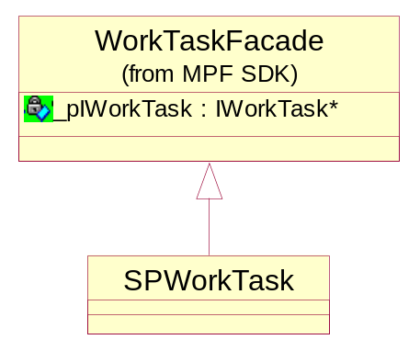
Service Provider WorkTask is a uniformed implementation of work task definition inherited from the WorkTask wrapper façade. Please refer to WorkTask Wrapper Façade for more details
Methods
TODO

Task Definition Loader
When the service provide task manager module is initialized, it loads the task definitions as its configuration. The task manage scans the task definition and validate the dependences for each task definition with the conditions of the local machine. Once a task definition passes the validation, it will be put in the active task type list.
The definition of a task is described in Task Definition Language; please refer to the later chapter for more details.

Internal Monitor Loop
The service provider is built-in with an internal monitor loop which performs the general monitoring on all the working task instances.
Items to monitor
TODO

Task Acceptor
Once the task definitions are loaded and some task types are active, the service provider is ready to host and perform some work task outside. Task Acceptor is the internal module of service provider to give an interface to outside to receive such requests.
The Task Acceptor opens a TCP listener port to receive the task requests.

Request Argument Mapping
Task Acceptor receives the task request at a command line format, such as
Exec <tasktypename> {[<task options>]}
Making the task request in such a command line format will lower the threshold for the outside user to kick off a task without preparing some complex task request structures.
Prior to the task request, the task definition language provides a mechanism to map every acceptable command option in the request to the task execution parameters, please refer to the chapter of for more details.
The Task Acceptor has an internal command line parser which is a Unix-getopt-like implementation. It parses the arguments from the task request line then maps the argument values to the task execution parameters. Please see Appendix 2 for more detail about the getopt usage.

Sample Task Request
An example can be expected to start a copy file task:
Exec “copyfile” –s c:\boot.ini –d c:\temp\boot.txt –i 0
where the string “copyfile” specifies the task type. For such a task, the option “-s” specifies the source file name and the option “-s” specifies the destination file name. And, the “-i” option mentions that this task is belongs to a session with session id “0” which is a dummy session.
The command line options can be defined either by user’s code in a worker application or the task definition language in the service provider.

Task Context in the Session Record
The MetaSession entities in the management node can also be trusted as the runtime context of a task. Since in the MPF definition, a task belongs to a session, it can get the context by getting session attributes. This is an extension method for a task to get its execution parameters.

Task Request API
The outside sends request to the service provider must go through the Task Acceptor listener port. The task request API is a bonus for the caller to communicate the task acceptor easier though it is possible to send the request thru a telnet-like client.
Although the command line formatted task requests give a lot of flexibility to outside to kick off a work task, a point may be raised later that in the case of a complex task request between two MPF nodes, a task request API will be required to provide a more powerful task request

Dummy Session
The all 0s session Id is reserved as a dummy session. A dummy session is an in-memory entity and will not have any mapped data storage. It exists and is maintained in every MPF nodes, a task belongs to such a dummy session is unnecessary to report its status to the management node which is normally not specified.
The dummy session makes an independent work task possible without breaking the rule that a single work task must belongs to a single session

Service Publisher
When the service provider is ready to accept some certain task types after validations, this internal module publish those task execution ability to the subscribed management nodes
Further more, in the periodic publishing appended to heat-beats fired by the worker control thread, the service publisher will also send the runtime capability to host the additional number of each certain task type.
In a word, the service publisher will spread the information about
- The abilities that which certain task types it can host
- The runtime capabilities that how many instances it can host additionally for each certain task type

Task Definition Language

Task Type Naming
The task type naming is to guarantee that the implementations of a same task type have a global unique identification. Those implementations maybe has some difference in their internal logic but they performs for the same purpose with same interfaces.
A task type name is a string consists of namespace part and task type name part
Namespace part
The namespace is a nested string with ‘::’ as the delimiters, for example “MPF::ZQ::”
Task type name part
The task type name is a string; it may be followed by some additional description such as subtype or version number delimited by ‘.’.
A completed task type name can be expected like the sample “MPF::ZQ::copyfile”. A case-sensitive matching of the whole string is required to seek for a task host ability of a worker node

Filter Enumeration
If a certain task type is defined on a worker node, the definitions must enumerate all the involved DirectShow-style filter objects (not class) in the beginning section. In every enumerated filter description:
- The filter object must be assigned with a task-definition-unique integer id that will be the reference to this object
- Must be given a class id of the containing COM control
- Must be given an interface id to access the filter object as
- As its sub-elements, all the pins involved of this filters object must be listed and assigned with filter-object-unique integer ids

Local Dependence Validation
The enumerated filters are the first dependences that must pre-registered on the worker node. Addition to that, a certain type of task may require some static local resources such as minimal physical memory size as its dependences. Those will be listed in this section

Pin Connections
All the pin connections are directive. The elements of pin connection will have the source pin id and the destination id.
The pin id in a connection element will be in the format of
<FilterObjId>.<PinId>
which is refer to a certain pin in the space of this task definition space.

Request Parameter Mapping
Every task may have its own parameter to initialize and start. This section defines all the required or optional parameters about a certain task type, in a parameter definition element:
- The parameter must be given a name
- The parameter must be given a option of the task request arguments to map, see Request Argument Mapping for details about task request argument

Sample Task Definition
<Task name=”MPF::ZQ::TranscodeMPG2TtoAVI” >
<Filter id=”1” classid=”1111111-1111-1111-11111111” >
<Interface id=”1” ifid=”2222222-2222-2222-2222-22222” >
<Pin id=”1” index=”001” />
<Pin id=”2” index=”003” />
</Filter>
<Filter id=”2” classid=”1111111-1111-1111-22222222” ifid=”2222222-2222-2222-2222-333333” >
<Pin id=”1” >
<Pin id=”2” >
</Filter>
<Connection sourcePin= “1.2”, destPin=”2.1” />
<Parameter name=”sourcefile” option=”s” required=”1” />
<Parameter name=”destfile” option=”d” required=”1” />
</Task>
<Task name=”MPF::ZQ::copyfile” >
…
</Task>
…

SRM Service

Service Provider Resolving

Resource Management Plug-in Architecture

User’s Interface

Task Collaboration

Tasks’ Relationships

Chain-up Tasks for a Session

Hot Swap

Error Handling and Fail-Overs
This section describes the error handling method and fail-over mechanism on the system architecture level.

Local Database vs External Database

Worker Application Service Fail-Over

Management Application Service Fail-Over

External Database Fail-Over

Supplementary Illustration [optional]
Any other topic that regarding to the project can be wrote here.

Issues and Considerations [optional]
Some unsolved issues or considerations can be listed here.

Appendix

Active Object Threading and Communication

Active Object Threading
Object-Threading
The basic thread object is defined like:
// -----------------------------
// class Thread
// -----------------------------
/// represents a thread of execution within an application
class Thread
{
public:
enum Status
{
///the thread is initial
INITIAL =1,
///the thread is running
RUNNING,
///the thread is disabled
DISABLED,
};

/// default constructor
/// @param pool where the thread pooled, each application can
/// maintain its own pool or use the global one
Thread(): _handle(NULL), _status(INITIAL)
{
_ handle = (HANDLE)_beginthreadex(NULL, stack, (exec_t)&Execute, (void *)this, CREATE_SUSPENDED, (unsigned *)&_tid);
if(!_hThread)
{
CloseHandle(_cancellation);
_cancellation = NULL;
throw(this);
}
}

///default destuctor
virtual ~Thread()
{ if(_handle!=NULL) close(); }

/// get the pool
ThreadPool* pool() { return &_pool; }

/// reset the thread pool
// void ResetThreadPool(ThreadPool& new_pool);

///return the thread handle, use for waitformultiobjects()
HANDLE handle(){ return _handle;}

///Starts execution!
bool start()
{
if (!_active)
{
_active = true;
ResumeThread(_hThread);
}
return 0;
}

static void Sleep(timeout_t msec);

///retrieve the current thread status
Status status(void)const{ return _status; }

///set the status of the current thread
void setStatus(int sts);

///query if the thread is still running.
bool isRunning(void)const{ return _status==RUNNING;}

///wait until the thread is ended or timeout
///@param timeoutMillis timeout
///@return return true if the thread is ended, timeout or error return false.
bool wait(DWORD timeoutMillis=INFINITE)const;

///close the job handle.
void close();

private:

/// the initial steps can be put here after start() is called
virtual bool init(void) { return true; };

/// should be Overrided! main steps for thread
virtual int run() =0;

/// you can do some clean work here, this functions is run in the thread.
virtual void final() {}

static DWORD WINAPI _execute(void *pVoid)
{
DWORD result=0;

Thread* pThis = (Thread*)pVoid;

try
{
if (pThis ==NULL || !pThis->init())
return result;

pThis->_status=RUNNING;
result=pThis->run();

pThis->_status=DISABLED;
if (pThis->_handle != NULL)
{
pThis->final();
}
}
catch (...) {}

/*if(pThis->_handle != NULL)
pThis->close();*/

// if User call delete this in final() this will cause
// access violation exception
//pThis->_status=DISABLED;
return result;
}

HANDLE _handle; ///thread handle

Status _status; ///thread status

/// define the following two constructor WITHOUT implementation to prevent
/// thread copying!
Thread(const Thread &);
Thread &operator=(const Thread &);
};
Worker Control Thread

Communication between Active objects and the control

GetOpt Description Sample
The Single UNIX ® Specification, Version 2
Copyright © 1997 The Open Group
Source: http://www.opengroup.org/onlinepubs/007908799/xsh/getopt.html
NAME
getopt, optarg, optind, opterr, optopt - command option parsing
SYNOPSIS
#include <unistd.h>
int getopt(int argc, char * const argv[], const char *optstring);
extern char *optarg;
extern int optind, opterr, optopt;
DESCRIPTION
The getopt() function is a command-line parser that can be used by applications that follow Utility Syntax Guidelines 3, 4, 5, 6, 7, 9 and 10 in the XBD specification, Utility Syntax Guidelines . The remaining guidelines are not addressed by getopt() and are the responsibility of the application.
The parameters argc and argv are the argument count and argument array as passed to main() (see exec). The argument optstring is a string of recognised option characters; if a character is followed by a colon, the option takes an argument. All option characters allowed by Utility Syntax Guideline 3 are allowed in optstring. The implementation may accept other characters as an extension.
The variable optind is the index of the next element of the argv[] vector to be processed. It is initialised to 1 by the system, and getopt() updates it when it finishes with each element of argv[]. When an element of argv[] contains multiple option characters, it is unspecified how getopt() determines which options have already been processed.
The getopt() function returns the next option character (if one is found) from argv that matches a character in optstring, if there is one that matches. If the option takes an argument, getopt() sets the variable optarg to point to the option-argument as follows:
- If the option was the last character in the string pointed to by an element of argv, then optarg contains the next element of argv, and optind is incremented by 2. If the resulting value of optind is not less than argc, this indicates a missing option-argument, and getopt() returns an error indication.
- Otherwise, optarg points to the string following the option character in that element of argv, and optind is incremented by 1.
If, when getopt() is called:
argv[optind] is a null pointer
*argv[optind] is not the character -
argv[optind] points to the string "-"
getopt() returns -1 without changing optind. If:
argv[optind] points to the string "--"
getopt() returns -1 after incrementing optind.
If getopt() encounters an option character that is not contained in optstring, it returns the question-mark (?) character. If it detects a missing option-argument, it returns the colon character (:) if the first character of optstring was a colon, or a question-mark character (?) otherwise. In either case, getopt() will set the variable optopt to the option character that caused the error. If the application has not set the variable opterr to 0 and the first character of optstring is not a colon, getopt() also prints a diagnostic message to stderr in the format specified for the getopts utility.
RETURN VALUE
The getopt() function returns the next option character specified on the command line.
A colon (:) is returned if getopt() detects a missing argument and the first character of optstring was a colon (:).
A question mark (?) is returned if getopt() encounters an option character not in optstring or detects a missing argument and the first character of optstring was not a colon (:).
Otherwise getopt() returns -1 when all command line options are parsed.
ERRORS
No errors are defined.
EXAMPLES
The following code fragment shows how one might process the arguments for a utility that can take the mutually exclusive options a and b and the options f and o, both of which require arguments:
#include <unistd.h>
int main (int argc, char *argv[ ])
{
int c;
int bflg, aflg, errflg;
char *ifile;
char *ofile;
extern char *optarg;
extern int optind, optopt;
. . .
while ((c = getopt(argc, argv, ":abf:o:")) != -1) {
switch (c) {
case 'a':
if (bflg)
errflg++;
else
aflg++;
break;
case 'b':
if (aflg)
errflg++;
else {
bflg++;
bproc();
}
break;
case 'f':
ifile = optarg;
break;
case 'o':
ofile = optarg;
break;
case ':': // -f or -o without operand
fprintf(stderr,
"Option -%c requires an operand\n", optopt);
errflg++;
break;
case '?':
fprintf(stderr,
"Unrecognised option: -%c\n", optopt);
errflg++;
}
}
if (errflg) {
fprintf(stderr, "usage: . . . ");
exit(2);
}
for ( ; optind < argc; optind++) {
if (access(argv[optind], R_OK)) {
. . .
}
This code accepts any of the following as equivalent:
cmd -ao arg path path
cmd -a -o arg path path
cmd -o arg -a path path
cmd -a -o arg -- path path
cmd -a -oarg path path
cmd -aoarg path path
APPLICATION USAGE
The getopt() function is only required to support option characters included in Guideline 3. Many historical implementations of getopt() support other characters as options. This is an allowed extension, but applications that use extensions are not maximally portable. Note that support for multi-byte option characters is only possible when such characters can be represented as type int.
The getopt() interface need not be reentrant.
FUTURE DIRECTIONS
None.
SEE ALSO
exec, getopts, <unistd.h>, the XCU specification.

